Children are in the Front Line of Israel’s Blockade of Gaza



# Report by Stephen McCloskey

***Ireland Palestine Solidarity Campaign*Children are in the Front Line of Israel’s Blockade of Gaza**

**Stephen McCloskey**

**Synopsis**

The Gaza Strip remains in the throes of a humanitarian crisis as Israel’s longstanding blockade of the territory is exacerbated by an energy crisis. Gaza’s young people are on the front line of this crisis as failing utilities like water and electricity and an inadequate diet have seen rampant rates of anaemia and diarrhoea. Meanwhile, the main provider of food, healthcare and education in Gaza, the United Nations Relief and Works Agency (UNRWA), has come under political attack in Israel and the United States, threatening the main institution that fills the gap between poverty and utter destitution. Against this international failure to challenge the illegal collective punishment of the 1.7 million people of Gaza, Palestinian civil society has called for international solidarity and Boycott, Divestment and Sanctions until international law is respected.

**The Blindfolded Generation**

Hady Mattar is a five year old boy playing among hundreds of young people in Gaza’s YMCA. He is easily distinguished from his peers by his bandaged hands covering severe burns sustained at home from a domestic electricity generator. Hady, like most of Gaza’s children, is paying the price of Israel’s blockade of the territory, which allows only a trickle of basic humanitarian items into the territory, and has been exacerbated by a fuel crisis that has shut down Gaza’s electricity supply for up to 12 hours a day.

Article 55 of the Fourth Geneva Convention states that 'In the context of an occupation, the occupying Power has the obligation to ensure that the civilian population in the occupied territory has access to sufficient food and medical supplies’. Yet Israel’s blockade has denied both to Palestinians. The economy of Gaza has been shattered, external markets cut off and the territory starved of investment and jobs. Most of Gaza’s 1.7m population have been propelled into chronic poverty with 38 percent surviving on less than $1.25 a day (2010 estimate, CIA Word Fact Book). The restrictions imposed by Israel on the import of food, on farmers access to their land and the 3 mile fishing limit has forced 1.1 million Palestinians to rely on the UN for food aid.

Children are on the front line of this blockade, their lives made even harder by the ongoing fuel crisis. Yasmeen El Khoudary, a young blogger from Gaza, recently described herself as being part of a ‘blindfolded generation’ physically separated from the outside world and psychologically damaged by the effects of isolation and disempowerment.

Electricity cuts are a constant feature of life under the blockade. Intensified by Israel in 2007, the blockade has severely restricted the supply of fuel to Gaza’s only power plant. The Hamas government in Gaza came to depend on supplies imported through the smuggling tunnels between Egypt’s Southern border at Rafah and the Gaza Strip. But since February 2012 the length and regularity of cuts have increased as Egypt has clamped down on smuggled fuel. The ostensible reasons given are a shortage of fuel in the Sinai region and Cairo’s insistence that the tunnels are an unsuitable and unsustainable means of importing industrial goods. However, what may also underpin this new regimen, is a sense that Israel’s ulterior purpose in maintaining the blockade is to have Cairo assume increasing responsibility for the welfare and movement of Palestinians – a responsibility that legally resides with Israel as the occupying power in Gaza.

What is indisputable are the effects of the crisis on utilities and hospital services with Oxfam suggesting that Gaza is ‘inching towards a total collapse of essential services’ with the health situation reaching ‘catastrophic proportions’ (February 2012). For children, the crisis has created a new of set of problems to be negotiated. Without electricity, water is not pumped to domestic consumers, something which regularly imposes on young people the task of collecting water in buckets for sanitation, cooking and washing. For those homes with access to fuel for domestic generators there is the endless drone of their engines and the health hazard for children. But for most of Gaza’s young people the main frustrations presented by electricity cuts are the lack of light for reading and study at night, and reduced access to computers and the internet. In a territory where education is considered the primary means of escaping poverty, electricity cuts can be at once disabling and dispiriting, negatively impacting on classroom performance and the development of young people.

**Health and Sanitation**

There are also worrying health implications for children resulting from the contamination and depletion of Gaza's underground aquifers*.* Gaza relies almost completely on its aquifer for fresh water, however today 95 percent of the water is unsafe for drinking without purification. The aquifer is polluted by a combination of nitrates from untreated sewage and fertilisers and sea water seeping into it. The blockade is further preventing the building of new water treatment plants and the re-construction of those destroyed during Israel’s 2008-09 assault on the territory. Within 4 years it is predicted that the aquifer will be unusable and that by 2020 the damage will be irreversible. Today the amount of clean water available to Gazans is less than the global World Health Organisation (WHO) standard of 100 litres per person per day. By 2020 this situation could reach catastrophic levels when the number of children is expected to increase by a further 200,000 (UN Report, Gaza in 2020 - A Liveable Place?).

Dr Fadel Jouda, General Director of Al Awda Hospital in Northern Gaza, the primary source of health care for Jabalia, the largest of the territory’s eight refugee camps, said that the majority of child cases presented to the hospital are diarrhoea and anaemia. The former are mostly caused by parasites in an untreated water supply and the latter by an iron deficiency in their diet. Dr Jouda believes that the processed food smuggled into Gaza through the tunnels is designed for a long shelf-life and lacks nutrition thus limiting the dietary intake of children.

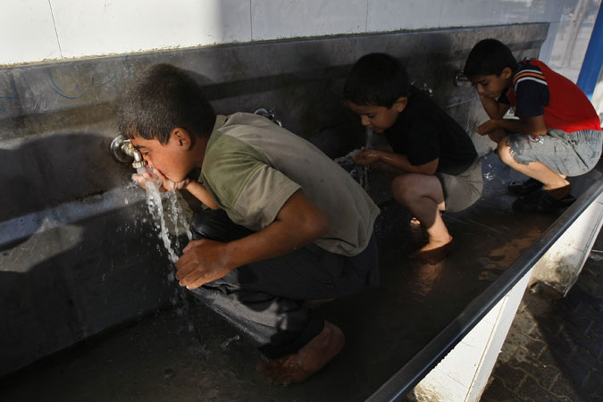

Figure 1 Children drink from a water purification station in Khan Yunis; *Mahmud Hams*.

A recent report from Save the Children found that 58 percent of school children in Gaza suffer from anaemia with 10 percent of children under ten subject to ‘chronic malnutrition’. In regard to sanitation the report found that ‘[I]n 2012 alone, three children drowned in pools of open sewage that cannot be adequately addressed as long as the blockade hinders sanitation development’ with sanitation-related diseases like typhoid fever and diarrhoea on the rise (2012:3). The report emphatically finds that ‘The blockade has been the single greatest contributor to endemic and long-lasting household poverty in Gaza’ (2012:2). It adds that ‘As a matter of urgent priority for the health and well-being of Gaza’s children, Israel must lift the blockade in its entirety to enable the free movement of people and goods in and out of Gaza, including to the West Bank and East Jerusalem’ (ibid).

**Gaza’s beleaguered education system**

With 44 percent of Gaza’s population under 14 years, the region’s beleaguered education system struggles to cope with the number of students. The United Nations Relief and Works Agency for Palestinian Refugees (UNRWA) provides health and education services to Gaza’s 1.1 million refugees as well as food aid and cash support. UNWRA has become a major provider of education services to Gaza’s children and currently has 221,000 elementary and preparatory students in 243 schools staffed by 7,700 teachers. These schools teach the local curriculum but have introduced additional programmes to target falling standards in Mathematics and Arabic as well as a dedicated Human Rights curriculum. The headteacher of one of UNRWA’s preparatory schools in Gaza city outlined some of the problems faced by his staff and students in such a highly populated and endemically poor region. A core issue is class-sizes with teachers struggling to work with over-crowded classrooms and unable to provide the kind of one-to-one attention needed by pupils. Moreover, the size of the student population and lack of new buildings has meant that 90 percent of schools operate double shifts meaning that pupils attend school for half-a-day to make way for more children using the same building in either the morning or afternoon. As a result, it has become extremely difficult in these schools to offer any kind of extra-curricular activities to pupils who sometimes receive additional tutelage in local youth and community centres. This crisis in education is only set to deepen further. By 2020 it is estimated that the number of school-age children will increase to 673,000 requiring a further 440 schools to be built. If Israel's blockade on construction materials continues an even greater number of children will be denied their universal right to an education.

Schools are also struggling to cope with the psycho-social problems of children, many of whom are experiencing the residual psychological effects caused by the trauma of Israel’s bombardment and invasion of Gaza in 2008-09. According to Israeli human rights organisation B’tselem, 344 minors were killed by the Israeli military during ‘Operation Cast Lead’ from a total of 1,390. But the abuses toward children have continued since then with Defence for Children International documenting another 30 cases of minors shot ‘whilst collecting building material or working near the border fence between the Gaza Strip and Israel’ in the period 26 March 2010 to 27 December 2011. This exposure to violence and stress has resulted in mental health problems for young people manifested through fear, sleeplessness, hyper-tension and a lack of motivation. While UNRWA has recruited 228 counsellors to work in schools, health and community centres, it is not enough given the kind of long-term counselling needed to manage stress and the size of Gaza’s school population.

Sadly, the most meaningful recreational outlet for children, UNRWA’s annual summer games programme, was cancelled this year owing to funding cuts. Summer games is normally offered to 250,000 children in a safe and structured play environment that offers art, theatre, sports, music and dance in 200 different locations. The programme has been badly missed by children over the hot summer months with life in the over-crowded refugee camps severely limiting opportunities for diversion from Gaza’s bleak concrete environment.

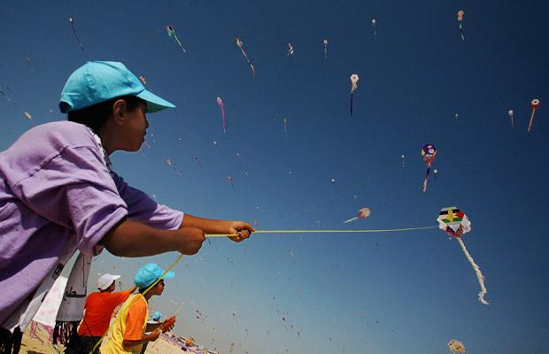

Figure 2 'The symbolism of thousands of children in one of the world’s most locked up communities, creating beautiful kites, letting them soar upwards, is truly beautiful.' Christopher Gunness UNRWA spokesman, 2010 summer games, *EPA*.

**UNRWA under attack**

The loss of summer games reflects UNRWA’s worsening financial situation caused largely by the failure of donor countries to fulfil their financial obligations to the Agency. Robert Turner, Director of UNRWA operations in Gaza, has identified an immediate funding shortfall of $20m needed to sustain emergency food aid programmes beyond September 2013. Should UNRWA be forced to reduce significant numbers of its 12,000 workforce in Gaza and implement cuts to emergency aid then food riots and social upheaval are a real possibility in a region where the UN believes ‘international assistance fills the gap between poverty and utter destitution’ (2012a).

UNRWA’s budget and remit in the Occupied Territories has recently come under increasing political scrutiny and attack. United States Senator Martin Kirk has questioned the designation of ‘refugee’ being applied to the descendants of those who were directly affected by the 1948 and 1967 wars. UNRWA, he suggests, ‘exists to perpetuate the refugee problem, not to solve it’ (23 May 2012). In May, the US Senate Appropriations Committee [unanimously passed](http://thecable.foreignpolicy.com/posts/2012/05/25/did_the_state_department_just_create_5_million_palestinian_refugees) the Kirk Amendment as part of the State Department and Foreign Operations Appropriations Bill for 2013. The bill requires the State Department to specify to Congress, for the first time, what proportion of the five million Palestinians supported by UNWRA, were actually displaced from their homes and what number are descendant of those refugees (*Haaretz*, 5 June 2012). Einat Wilf, a member of the Knesset, the Israeli parliament, has also taken up this mantle and suggests that ‘Only UNRWA grants an unparalleled automatic hereditary refugee status’ and aims to appeal to parliamentary committees that approve UNRWA contributions to disconnect aid from refugee status (1 February 2012).

Victor Kattan,Director of Al-Shabaka, The Palestinian Policy Network, argues that ‘the real goal of the (Kirk) amendment is clear: It is an attempt to redefine the number of Palestinian refugees receiving aid from UNRWA with a view to limiting its budget, which is heavily dependent on U.S. aid’. He adds that UNRWA’s definition of a Palestinian refugee ‘is recognized by the UN High Commissioner for Refugees and is the organization’s standard practice for all refugees around the world’ (30 May 2012). By reducing the number of refugees, the Kirk amendment may also be aiming to limit the Palestinian right to return to those directly forced from their lands in 1948. With the right steps taken, Einat Wilf sees the ‘deflated’ number of refugees ‘lowered to 30,000’.

**Collective Punishment**

While these political machinations continue, the hopes for any kind of rapprochement or meaningful dialogue toward ending the Middle-East conflict seem as distant as ever. Israel’s blockade of Gaza, which was severely intensified in 2007, has been condemned by the International Committee of the Red Cross as ‘collective punishment’ (*ICRC Statement*, 14 June 2010) - a war crime under the Fourth Geneva Convention. Despite protestations from Israeli spokesman, Mark Regev, that ‘Our goal is to try to hurt the Hamas regime, not to see the people of Gaza suffer. We don't see the people of Gaza as our enemy’ (*Guardian*, 8 June 2012), the ICRC found ‘The whole of Gaza's civilian population is being punished for acts for which they bear no responsibility. The closure therefore constitutes a collective punishment imposed in clear violation of Israel's obligations under international humanitarian law.’

Evidence regarding the alleged effectiveness of the blockade further points to spikes in support for Hamas on the back of Israeli aggression in Gaza. For example, an opinion poll taken in Gaza and the West Bank following Operation Cast Lead in 2008-09 showed Hamas leader Ismail Haniyeh receiving the majority of support (47 percent) from those canvassed (*Haaretz*, 9 March 2009). It is unlikely, therefore, that a continuation of the blockade will loosen Hamas’s control of Gaza but will undoubtedly worsen the plight of its people. As Chris Gunness, UNRWA's spokesman, put it: ’It is hard to understand the logic of a manmade policy which deliberately impoverishes so many and condemns hundreds of thousands of potentially productive people to a life of destitution’ (UN, 2011).

Three factors have helped to release the pressure valve on Hamas within Gaza. First, the tunnels have allowed imported goods into Gaza even if Israel’s blockade has tightly restricted exports. Second, the removal of Hosni Mubarak from power in Egypt has seen a relaxing of the movement of Palestinians from Gaza through the Rafah Crossing. And third, Israeli’s deadly attack on the Mavi Marmara, the flagship of a Gaza flotilla of vessels aiming to break the siege, caused international outrage and a slight easing of the blockade. But Hamas’s recent dispute with Egypt over fuel supplies shows that the tunnels are not a sustainable means of supplying Gaza with domestic and industrial goods. Moreover, Hamas’s decision in July 2012 to suspend the registration of voters in Gaza for a forthcoming election is likely to further delay the prospect of reconciliation with Fatah and a more unified Palestinian approach to governance and negotiations (PCHR, 2012).

For Gaza’s youth, the political wrangling over fuel and internal disputes between Fatah and Hamas, have worsened their living environment and increased their vulnerability to poverty, sickness and stress. The primary factor underpinning this humanitarian crisis is Israel’s blockade which, according to Amnesty International ‘constituted collective punishment – a breach of international law – and particularly affected children and the sick’ (2012:187). The Palestinian Centre for Human Rights (PCHR) believes that ‘The illegal closure of the Gaza Strip has become institutionalized. Through the provision of aid, international organizations are underwriting the cost of the occupation and this illegal policy’ (June 2012). The PCHR has called for advocacy that moves governments beyond international aid that tries to manage the effects of the blockade toward concerted political action that will lift the siege.

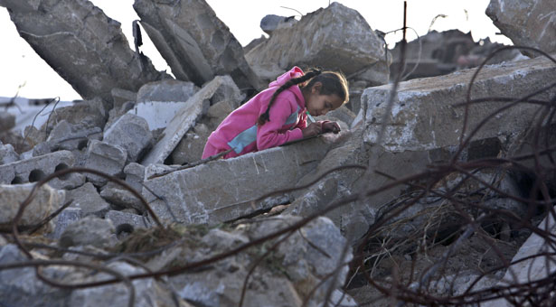

Figure 3 Girl writes note on the ruins of her destroyed home, Jabalia, *Adel Hana*.

## Conclusion

The continuing illegal blockade of Gaza and the failure of States and the international organisations of the UN and the EU to require compliance with International Humanitarian and Human Rights norms must be a priority for campaigners around the world. To challenge this culture of impunity in 2005 Palestinian Civil Society initiated the non-violent boycott, divestment and sanctions movement (BDS). Consciously modelled upon the South African anti-Apartheid campaign, BDS relies upon the strength of international civil society to point international governments in the direction of justice and human rights. Over several years BDS has gathered many international endorsements, including that of that of the Irish Congress of Trade Unions. And international BDS campaigners can also draw upon the resolve of Gaza’s young people, like [Shahd Abusalama](http://electronicintifada.net/blogs/shahd-abusalama)**,** who said, ‘No matter how much Israel's oppression escalates, their plans are bound to fail. Their inhumanity does nothing but increase our humanity. We're ready to take the challenge and fight for what we have always deserved: justice, freedom, and equality’ (*Guardian*, 9 June 2012).

Stephen McCloskey August 2012

**About the Ireland Palestine Solidarity Campaign**

The Ireland Palestine Solidarity Campaign (IPSC) was set up in late 2001 by Irish human rights and community activists, academics and journalists who were deeply concerned with the current situation in the Occupied Territories. In partnership with Palestinians now living in Ireland the IPSC was formed to provide a voice for Palestine in Ireland.

We are an independent, non-party political organisation, run by volunteers all committed to a just and sustainable peace in the Middle East.

The IPSC campaigns for justice for the Palestinian people, through raising public awareness about the human rights abuses in the occupied territories, the violations of international law and the historical causes of the injustices to the Palestinians that lie at the heart of the Israeli/Palestinian conflict.

The IPSC lobbies the Irish government and the EU, campaigns on the streets and urges for a vigorous Boycott, Divestment and Sanctions campaign similar to the one that played a part in ending Apartheid in South Africa. The IPSC also holds public talks with Israeli and Palestinian speakers, publishes information booklets and fact sheets, and holds a variety of Palestinian cultural and fundraising events.

For more information about the IPSC, visit our website at www.ipsc.ie. You can also call our national office on 01-6770253 or email us on info@ipsc.ie.

**References**

Amnesty International (2012), *Amnesty International Report 2012: The State of the World’s Human Rights*, Amnesty International, London.

Boycott, Divestment, Sanctions (BDS) Movement, <http://www.bdsmovement.net/> [accessed 31 July 2012].

B’Tselem, ‘Fatalities during “Operation Cat Lead”’ <http://old.btselem.org/statistics/english/casualties.asp?sD=27&sM=12&sY=2008&eD=18&eM=01&eY=2009&filterby=event&oferet_stat=during> [accessed 29 July 2012]

Defence for Children International, 17 January 2012

<http://www.dcipalestine.org/sites/default/files/ua_4_10_children_of_the_gravel_update_17_jan__2012.pdf> [accessed 29 July 2012]

*Guardian*, ‘Gaza hit by power crisis’, 1 March 2012

*Guardian*, ‘Live Blog’, <http://www.guardian.co.uk/world/blog/2012/jun/08/gaza-live-blog>, 8 June 2012 [9 June].

*Haaretz*, ‘Palestinians: Refugees Forever?’, 5 June 2012, <http://www.haaretz.com/opinion/palestinians-refugees-forever-1.434508>, [accessed 30 July 2012].

*Haaretz*, ‘Poll: Hamas more popular after Gaza offensive’, 9 March 2009, http://www.haaretz.com/news/poll-hamas-more-popular-after-gaza-offensive-1.271757, [accessed 30 July 2012].

International Committee of the Red Cross, ‘Gaza Closure: Not Another Year’ 14 June 2010,

<http://www.icrc.org/eng/resources/documents/update/palestine-update-140610.htm> [accessed 30 July 2012].

Irvine, Richard,’ Israel’s cynical campaign to pit Arab Jews against Palestinian refugees’, *The Electric Intifada*, 1 July 2012,

*Jerusalem Post*, ‘Wilf to Ambassadors: UNRWA an Obstacle to Peace’, 2 January 2012. <http://www.jpost.com/DiplomacyAndPolitics/Article.aspx?id=256093> [accessed 30 July 2012].

Kattan, Victor,” 'UNRWA reform' effort will harm Middle East peace effort”, The Hill’s Congress Blog, <http://thehill.com/blogs/congress-blog/foreign-policy/230065-unrwa-reform-effort-will-harm-middle-east-peace-effort>, [accessed 30 June 2012).

Oxfam, ‘Gaza nearing total blackout’, 19 February 2012, <http://english.pnn.ps/index.php/national/896-gaza-nearing-total-blackout-oxfam-quote-and-weekly-gaza-update> [accessed 29 July 2012].

Palestinian Centre for Human Rights (PCHR),‘5 Years and Counting: International Organisations and Donors Continue to Fund Israel’s Illegal Closure of the Gaza Strip’, 13 June 2012, <http://www.pchrgaza.org/files/2012/closure%20report13-6.pdf> [accessed 31 July 2012].

Palestinian Centre for Human Rights (PCHR),‘PCHR Disapproves Hamas' Decision to Halt Voter Registry Update by the CEC’, 2 July 2012.

United Nations Relief and Works Agency for Palestine Refugees in the Near East (UNRWA), Emergency Appeal 2012a, <http://www.unrwa.org/userfiles/2011120681236.pdf> [accessed 30 July 2012].

United Nations Relief and Works Agency for Palestine Refugees in the Near East (UNRWA), Gaza Field Office Pack, 2012b.

Save the Children (2012), ‘Gaza’s Children: Falling Behind; The Effect of the Blockade on Child Health in Gaza’, <http://www.savethechildren.org.uk/resources/online-library/gazas-children-falling-behind>, June 2012 [accessed 25 July 2012].

Scoop Independent News, ‘Turner: Gaza Siege Affected the Region and UNRWA Operations’, 7 June 2012, <http://www.scoop.co.nz/stories/WO1206/S00116/turner-gaza-siege-affected-the-region-and-unrwa-operations.htm>, [accessed 29 July 2012].

Shahd Abusalama’s blog, <http://electronicintifada.net/blogs/shahd-abusalama> [accessed 31 July 2012].

UN News Centre, ‘Israeli blockade of Gaza hurts employment and wages’, 13 June 2011.

UN Report, ‘Gaza in 2020 - A Liveable Place?’ August 2012

World Health Organisation, ‘Health conditions in the occupied Palestinian territory, including east Jerusalem, and in the occupied Syrian Golan’, 16 May 2012, <http://unispal.un.org/UNISPAL.NSF/0/71094D7E6883B97F85257A02004FF761>[accessed 20 July 2012].

Yasmeen El Khoudary’s blog, <http://yelkhoudary.blogspot.co.uk/> [accessed 28 July 2012].

Cover Image: Boy in Gaza, *Mohammed Salem*

Stephen McCloskey is the Director of the Centre for Global Education